WEEK 4
1.
import java.util.Scanner;
import java.io.*;
class miss{
public static void main(String[] args){
Scanner sc= new Scanner(System.in);
int n=sc.nextInt();
int arr[]=new int[n-1];
for(int i=0;i<n-1;i++){
arr[i]=sc.nextInt();
}

for(int i=0;i<n-1;i++){
for(int j=i+1;j<n-1;j++){
if(arr[i]>arr[j]){
int temp=arr[i];
arr[i]=arr[j];
arr[j]=temp;
}
}
}
for(int i=0;i<n-1;i++){
if(i+1==arr[i]){
continue;
}
else{
System.out.print(i+1);
break;
}
}
}
}
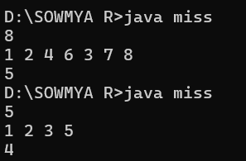

2.
import java.util.*;
import java.io.*;
class zero{
public static void main(String[] args){
Scanner scan= new Scanner(System.in);
int n=scan.nextInt();
int a[]=new int[n];
for(int i=0;i<n;i++){
a[i]=scan.nextInt();
}
int c=0;
for(int i=0;i<n;i++){
if(a[i]!=0){
a[c]=a[i];
c++;
}
}
while(c<n){
a[c]=0;
c++;
}
for(int i=0;i<n;i++){
System.out.print(a[i]+" ");
}
}
}
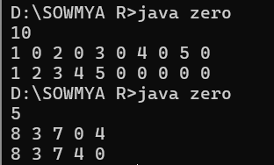

3.
import java.util.Scanner;
import java.io.*;
class row{
public static void main(String[] args){
Scanner scan= new Scanner(System.in);
String s=scan.nextLine();
int currentValue=0,total=0,prev=0;
for (int i = s.length() - 1; i >= 0; i--) {
char currentChar = s.charAt(i);

switch (currentChar) {
case 'I':
currentValue = 1;
break;
case 'V':
currentValue = 5;
break;
case 'X':
currentValue = 10;
break;
case 'L':
currentValue = 50;
break;
case 'C':
currentValue = 100;
break;
case 'D':
currentValue = 500;
break;
case 'M':
currentValue = 1000;
break;
}
if (currentValue < prev) {
total -= currentValue;
}
else {
total += currentValue;
}
prev=currentValue;
}
System.out.println(total);
}
}

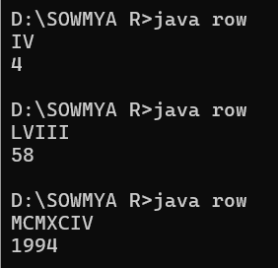
4.
import java.util.*;
class palindrome
{
public static void main(String args[])
{
Scanner sc = new Scanner(System.in);
String s = sc.nextLine();
String r ="";
String p ="";
s=s.toLowerCase();
for(int i=0;i<s.length();i++)
{
char ch = s.charAt(i);
if(ch>='a' && ch<='z')
{
r+=ch;
}
}
int n = r.length();
for(int i=0;i<n;i++)
{
p+=r.charAt(n-i-1);
}
if(p.equals(r))
{
System.out.println("True");
}
else
{
System.out.println("False");
}
}
}
